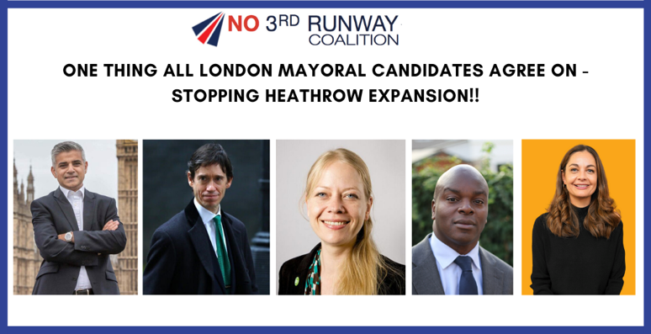
NO 3RD RUNWAY COALITION

PRESS RELEASE

1 MARCH 2020

For immediate use

ALL MAIN LONDON MAYOR CANDIDATES COME OUT AGAINST HEATHROW EXPANSION

The five main candidates for the London Mayoral election on 7th May have come out against Heathrow expansion in a week that saw the Court of Appeal rule against the Government’s plans on grounds that climate change was not taken into account when the plans were put to Parliament in 2018.

Sadiq Khan, Labour candidate and incumbent Mayor of London, has supported the legal challenge against a third runway and visited Harmondsworth village on 29th February to offer support for those who would face losing their homes if the runway were ever to go ahead. Khan said (2):

“I’m really grateful that the Court of Appeal held that the third runway shouldn’t happen, it’s legally fatal.

“This is a landmark judgment and is probably the most important environmental case for a generation. We’ve brought this case because we think a new runway at Heathrow has serious consequences for climate change, for air quality, for noise pollution and for the road and rail network and also for the quality of life for our city.”

Conservative candidate Shaun Bailey attended the Court of Appeal ruling on 27th February, saying (3) to campaigners and residents outside the High Court that:

“Heathrow expansion was never the answer. My opposition to a third runway at Heathrow is based on the clear evidence which incompatible with my plan to clean up air in London. But more than that, the wider evidence base and the wider case for expansion at Heathrow is flawed.”

Announcing his opposition to a third runway, in response to a question at a Tower Hamlets event on 29th February (4), independent candidate Rory Stewart said:

“It’s important to admit when you’re wrong. All the time I have spent in west London particularly around the airport, have shown me that the environmental impacts of having an airport like that are very, very extreme and the court ruling has now said Heathrow is not meeting its commitments on carbon.

“My suspicion is that it’s not meeting its commitments on noise pollution, on air pollution and other commitments. This I think means the third runway should not happen and as Mayor of London I will be arguing against the runway on those grounds.”

Liberal Democrat Candidate Siobhan Benita (5), who was previously in favour of expansion when running as an independent candidate in 2012, said that:

“This is an excellent decision for a greener London. Heathrow expansion is not compatible with our climate change commitments in the Paris Agreement. Now the Government must put an end to this polluting project.”

Sian Berry, Green Mayoral candidate is a long-standing opponent of a 3rd runway and all other airport expansions. Berry said (6) that the Court of Appeal ruling on Heathrow was “The right conclusion on Heathrow at last. Bigger airports have no place in a world facing a climate emergency.”

Paul McGuinness, Chair of the No 3rd Runway Coalition, said:

“There’s no truer barometer of London’s view on Heathrow expansion than the city’s mayoral candidates. And it’s because they have their ears close to ground, across the whole metropolis, that they are all vehemently opposed to any expansion at Heathrow.”

ENDS.

Notes

- Picture attached
- Speaking to residents in Harmondsworth on 29th February https://twitter.com/StopHeathrowExp/status/1234049853149327360 and to BBC News on 27th February https://twitter.com/BBCPolitics/status/1232994525150404608
- https://twitter.com/ShaunBaileyUK/status/1233017757102493698
- https://twitter.com/debbiesimone123/status/1234022225805705216
- https://twitter.com/SiobhanBenita/status/1232976456180957190
- https://twitter.com/sianberry/status/1232983548296122368

For more information, contact:

- Rob Barnstone on 07806947050 or rob@no3rdrunwaycoalition.co.uk

